PLSO 7439
Plant and Soil 111, 17-23 (1988)
© Kluwer Academic Publishers
Row spacing effects on N₂-fixation, N-yield and soil N uptake of intercropped cowpea and maize

CHRISTOPHER VAN KESSEL¹ and JOANN P. ROSKOSKI
University of Hawaii, NifTAL Project, P.O. Box "O", Paia, HI 96779, USA¹. Present address: Department of Soil Science, University of Saskatchewan, Saskatoon, Saskatchewan, Canada, S7N OWO Received 26 June 1987. Revised April 1988
Key words: intercrop, monocrop ¹⁵N-depleted ammonium sulphate, ¹⁵N-dilution, N₂-fixation, N-transfer, Vigna unguiculata, yield independent, Zea mays
Abstract
In the tropics, cowpea is often intercropped with maize. Little is known about the effect of the intercropped maize on N₂-fixation by cowpea or how intercropping affects nitrogen fertilizer use efficiency or soil N-uptake of both crops. Cowpea and maize were grown as a monocrop at row spacings of 40, 50, 60, 80, and 120 cm and intercropped at row spacing of 40, 50, and 60 cm. Plots were fertilized with 50 kg N as (NH₄)₂SO₄; microplots within each plot received the same amount of ¹⁵N-depleted (NH₄)₂SO₄. Using the ¹⁵N-dilution method, the percentage of N derived from N₂-fixation by cowpea and the recovery of N fertilizer and soil N-uptake was measured for both crops at 50 and 80 days after planting.
Significant differences in yield and total N for cowpea and maize at both harvest periods were dependent on row spacing and cropping systems. Maize grown at the closer row spacing accumulated most of its N during the first 50 days after planting, whereas maize grown at the widest row spacing accumulated a significant portion of its N during the last 30 days before the final harvest, 80 days after planting.
Overall, no significant differences in the percentage of N derived from N₂-fixation for monocropped or intercropped cowpea was observed and between 30 and 50% of its N was derived from N₂.
At 50 DAP, fertilizer and soil N uptake was dependent on row spacing with maize grown at the narrowest row spacing having a higher fertilizer and soil N recovery than maize grown at wider spacings. At 50 and 80 DAP, intercropped maize/cowpea did not have a higher fertilizer and soil N uptake than monocropped cowpea or maize at the same row spacing. Monocropped maize and cowpea at the same row spacing took up about the same amount of fertilizer or soil N. When intercropped, maize took up twice as much soil and fertilizer N as cowpea. Apparently intercropped cowpea was not able to maintain its yield potential.
Whereas significant differences in total N for maize was observed at 50 and 80 DAP, no significant differences in the atom % '⁴N excess were observed. Therefore, in this study, the atom % '⁴N excess of the reference crop was yield independent. Furthermore, the similarity in the atom % '⁴N excess for intercropped and monocropped maize indicated that transfer of N from the legume to the non-legume was small or not detectable.
Introduction

While intercropping has been practiced for centuries, the interest of agricultural scientists in such crop production systems has only recently increased (Willey, 1979a; Willey, 1979b).
Conflicting reports exist about whether a non
17
legume benefits from N supplied by an intercropped legume. Whereas the N contribution of the intercropped legume to maize has been estimated at 40 kg ha⁻' (Willey, 1979a), others did not find any evidence for such N benefit (Searle et al., 1981; Wahua and Miller, 1978a). Using "N-enriched (NH₄)₂SO₄, Eaglesham et al. (1981) found that
18 van Kessel and Roskoski

maize intercropped with cowpea showed lower atom % ¹⁵N excess values than the monocropped maize. This, according to the investigators, was caused by excretion of fixed N by the legume and subsequent uptake of N by the maize. Recently an increase in total N of sorghum intercropped with nodulating soybeans was reported, but not when intercropped with non-nodulating soybeans (Elmore and Jackobs, 1986). This beneficial effect of the nodulating soybean on sorghum was attributed to transfer of N from the legume to the non-legume.
N₂-fixation is an energy demanding process and dependent on photosynthesis (Bath et al., 1958). If the intercropped non-legume is taller than the legume, shading will occur and photosynthesis and subsequently N₂-fixation will be reduced (Trang and Giddens, 1980; Wahua and Miller, 1978b). Plant density also has an effect on N₂-fixing activity. A reduction in N₂-fixation per plant at increasing plant density has been reported (Hardy and Havelka, 1976). However, total N₂-fixing activity per area basis appeared to be less variable (Hardy and Havelka, 1976).
A possible advantage of intercropping legumes with non-legumes may be a more efficient use of soil nutrients. If both species have different rooting and uptake patterns, a more efficient use of the available nutrients may occur and higher total N-uptake in intercropping systems with monocropping systems have been reported (Dalal, 1974; Mason et al., 1986). It is unclear, however, if the greater nutrient uptake is the cause or the effect of higher yield potential (Willey, 1979a).
The basic assumption in ¹⁵N-dilution studies is that if a plant is confronted by a ¹⁵N and '⁴N labelled nitrogen source it will not discriminate between them and that N-uptake will be proportional to the amount of each N-source available (Fried and Broeshart, 1975). Inherent to this assumption lies the conclusion that the value for atom % ¹⁵N of the reference crop is N-yield independent (Fried, 1985). Or stated differently, the atom % ¹⁵N of the reference crop is independent of size and total N accumulated in that plant. Although this conclusion has been accepted widely, no or few studies have tested this derived assumption for its accuracy.
This study examined the effect of intercropping and row spacing on N2-fixation by cowpea and on

yield, total N, soil N and fertilizer N uptake by cowpea and maize. In addition it examines the effect of total N of the reference crop on atom % ¹⁵ N.

Materials and methods

The experiment was conducted at the University of Hawaii, NifTAL Project, Kuiaha experimental site located on the island of Maui, Hawaii. The soil is classified as a clayey, ferritic, isohyperthermic Humoxic Tropohumult weathered from basic igneous rock and volcanic ash. Mean average rainfall is 2110 mm; altitude is 320 m. The soil was limed with 2400 kg ha⁻' dolomite limestone and between 6600 and 7200 kg ha' agricultural limestone depending on initial pH (4.8-5.5) to bring the field to a final pH of 6.1. Before planting, blanket fertilizer treatments of 600 kg P ha⁻' as Ca(H₂P0₄)₂, 370 kg Kha⁻' as K₂SO₄, 15 kg Zn ha⁻' as, ZnS0₄, 5 kg B ha⁻' as H₃BO₃ and 2 kg Mo ha⁻' as Na₂MoO₄ were applied.

Experimental design

Plots were arranged in a split-plot design with 5 replications. Main plot treatments consisted of spacing distances of 40, 50, 60, 80, 100, or 120 cm between rows. Subplot treatments consisted of maize [Zea mays L.] and cowpea [ Vigna unguiculata (L.) Walp] monocropped in rows 40, 50 or 60 cm apart, depending on the main plot treatment. Maize (Hawaiian Super Sweet #7) and cowpea (California Black-eye) were intercropped in alternate rows with distances between maize and cowpea rows of 40, 50, or 60 cm. This resulted in distances of 80, 100, and 120 cm between 2 rows of maize or cowpea, depending on the main plot treatment. To assess the effect of a row spacing of 80, 100, and 120 cm between 2 consecutive rows of intercropped cowpea, maize and cowpea were also monocropped at spacings of 80, 100, and 120 cm in addition to the 40, 50, and 60 cm.
Within a row, maize was planted at 7.5 cm intervals and cowpea at 2.5 cm intervals. These were later thinned to 15 cm and 5 cm for the maize and cowpea, respectively. Cowpea seeds were coated with peat-based inoculant containing equal num-
100
bers of Rhizobium strains, TAL 173, TAL 209, and TAL 658, providing approximately 3.2 x 10⁶ rhizobia per seed. Gum arabic was used as a sticking agent.
¹⁵N application
¹⁵N-depleted (NH₄)₂S0₄(0.0016 atom % ¹⁵ N) at a rate of 50 kg ha⁻' was applied two days after planting to 1.5 x 12.5 m ¹⁵N microplots in the center of each main plot. ¹⁵N⁻(NH₄)₂SO₄ required for one main plot was applied in 301 of water. To ensure adequate ¹⁵N microplots sizes for the maize and cowpeas, intercropped at 50 and 60 cm row distances, an additional area of 0.625 m² for the maize-cowpea intercropped at 50 cm row spacing and 1.125 m² for the maize-cowpea intercropped at 60 cm row spacing was added on both sides of the ¹⁵N microplot. Unlabelled (NH₄)₂S0₄ at the same rate of 50 kg ha⁻' was applied to the rest of the subplot. Drip irrigation lines were placed 50 cm apart over the whole experimental area. Irrigation was carried out to maintain soil moisture at 0.3 bar tension. During the first three weeks after planting, insects were controlled with Dimethoat 267 (0.0 Dimethyl S- N-methylcarbamoylemethyl; made by the Crystal Chemical Col, Houston, TX) phosphorodithionate at a rate of 72 g ha⁻' .
Plant sampling and analysis
Maize and cowpea were harvested 50 and 80 days after planting. The first harvest period corresponded to the late vegetative growth state of the maize and the R 1 growth stage of the cowpea. At the final harvest, maize was at the R4 or "dough" stage and cowpea at maturity. Three plants of each species were selected from the middle of ¹⁵N microplots for ¹⁵N analysis. The remainder of the ¹⁵N microplot and 1.5 m of all the center rows were harvested for yield data. At harvest, fresh weight of all harvested plants was taken and a subsample removed for moisture content determination. Maize was not separated into different plant parts at either harvest periods and cowpea only at the final harvest. Yield and ¹⁵N samples were dried at 65 °C until constant weight was obtained.
Plant parts were ground to pass a 0.45-mm
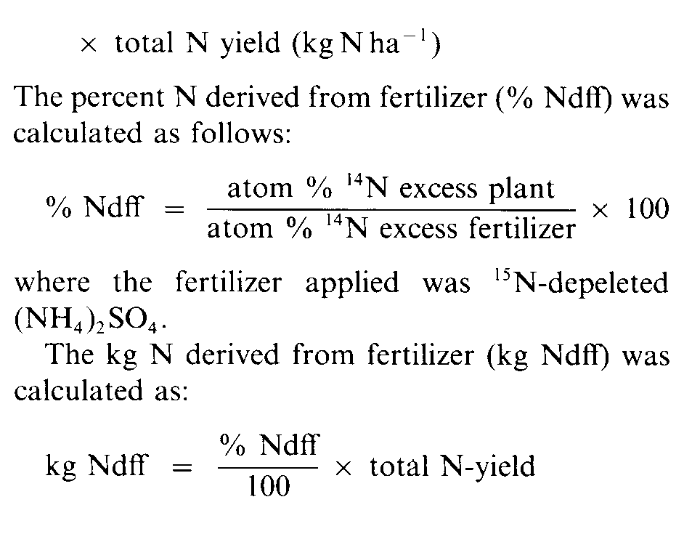
Nitrogen and intercropped maize/cowpea 19
screen. The mill was cleaned between samples. Ground samples were digested in H₂SO₄ and analyzed for total N including N0₂ and N0₃ (Bremner and Mulvaney , 1982). Digestions were made alkaline with 13 N NaOH and steam distilled for seven minutes in an all glass steam distillation apparatus. Distillates were collected in 0.02 N H₂ SO₄. To avoid cross contamination, 20 ml of ethyl alcohol was distilled between each sample. Subsamples of the distillates were analyzed for total N using the indophenol blue method (Keeney and Nelson, 1982). The rest of the distillate was adjusted to a pH of 4, concentrated and analyzed for ¹⁵N. Analysis were carried out at the Isotope Service Inc., Los Alamos, New Mexico, USA.
The percent N derived from N₂-fixation (% Ndfa) was calculated as follows:
grown at the higher plant densities yielded more N than maize and cowpea grown at lower plant densities. At 80 DAP, monocropped cowpea still showed the highest N-yield for the highest plant population whereas for monocropped maize no apparent differences between plant density and total N yield was observed. However, intercropped maize grown at the lowest density produced the highest total N. For intercropped cowpea, plant density had no effect on total-N. It is noteworthy that maize planted at the closest row spacing did not increase in total N between 50 and 80 DAP, whereas total N for intercropped maize grown at a row spacing of 60 cm or monocropped at a row spacing of 100 and 120 cm doubled or significantly increased between 50 and 80 DAP. This would also indicate that maize grown at the 40 cm row spacing was under more N stress than maize grown at a wider row spacing.
A reduction in atom % ¹⁴N excess was observed in maize between 50 and 80 DAP (Table 3). Overall, changes in atom % ¹⁴N excess in maize between 50 and 80 DAP appeared in total N between the two harvest periods. For. example, total N ha⁻' or total N plant⁻' of monocropped maize grown at a row spacing of 40 cm did not change between 50 and 80 DAP and the difference in atom % ¹⁴N excess between the two harvest periods was small. However, monocropped maize, planted at a row spacing of 120 cm or intercropped at 60 cm, doubled its total N between the two harvest periods and the value for atom % ¹⁴N excess was reduced
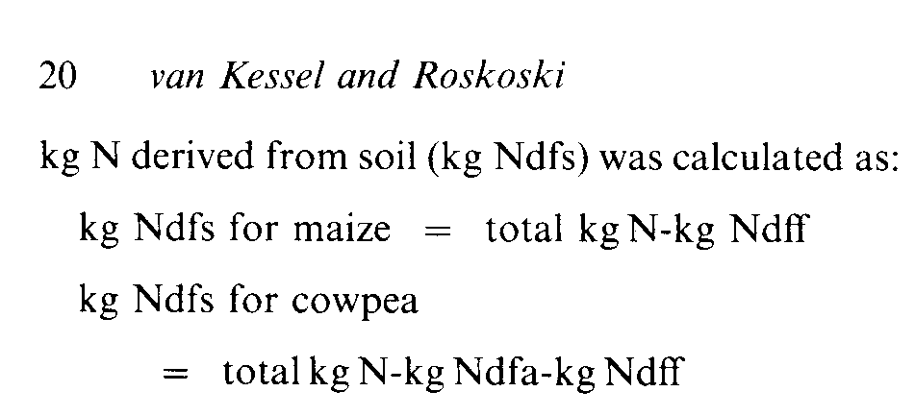
Results and discussion

Significant differences in yield of maize and cowpea were observed at 50 and 80 DAP (Table 1). Two weeks after the first harvest, cowpea suffered from an insect infestation which resulted in a partial leaf fall and may have reduced the yield at the final harvest period. Closer row spacing increased yield and the smallest row spacing resulted in the highest yield for maize and cowpea. Yield of intercropped cowpea was less than half that of monocropped cowpea at the same row spacing. In contrast, the yield of intercropped maize was significantly more than half the yield of monocropped maize at the same row spacing. It is apparent that the effect of intercropping on yield was more severe for cowpea than for maize and that cowpea could not maintain its yield potential when intercropped with maize.
At 50 DAP, there was a tendency for a higher total N ha⁻' for monocropped cowpea as compared with monocropped maize, although this pattern was not present at 80 DAP (Table 2). Furthermore, at 50 DAP, monocropped maize and cowpea
by 0.01. This reduction in atom % ¹⁴N excess is caused by a decrease in the ratio of fertilizer to soil N availability as a function of time. However, fertilizer-N was still available and the amount of fertilizer-N recovered increased between 50 and 80 DAP when higher total N yields were found at 80 DAP as compared with 50 DAP (Table 2 and 5). The same phenomenon also occurred with cowpea and lower atom % ¹⁴N excess values were observed
Nitrogen and intercropped maize/cowpea 21

for monocropped cowpea at the different row spacings, although less than for the intercropped cowpea.
At 50 DAP total N per plant of monocropped maize grown at 120 cm row spacing was about twice that of monocropped maize grown at the smallest row spacing of 40 cm. At 80 DAP, this value became 3.7 (Table 3). In contrast with those large differences in total N per plant, the atom
¹⁴N excess remained the same for maize grown at the different plant densities, harvested at the same time. This strongly supports the conclusion that the atom % ¹⁵N value of the reference crop is N-yield independent (Fried, 1985).
In previous studies, transfer of N from an N,fixing legume to an intercropped non-legume has been suggested for maize/cowpea (Eaglesham et al., 1981), sorghum and soybean (Elmore and Jackobs, 1986) and estimated for intercropped groundnut/ maize (Willey, 1979a). If any significant transfer of N from the legume to the non-legume had occurred, the atom % ¹⁴N excess of the intercropped maize should have been lower than the value for the monocropped maize. Because no differences in atom % ¹⁴N excess were observed (Table 3), little or no N-transfer from the legume to the intercropped maize had occurred.
At both harvest periods, the % Ndfa in cowpea was largely independent of row spacing or cropping system and, overall, cowpea derived between 30 and 50% of its N from N,-fixation (Table 4).
Apparently the intercropped maize did not stimulate, through depletion of available soil N, the intercropped cowpea into higher N₂-fixation rates.
Total kg N fixed, which is a function of total N yield, varied more between cropping systems than between row spacing (Table 4). Consistent with this dominant effect of total N yield at 50 DAP the amount of kg N fixed in the intercropped cowpea was about 50% of the amount of N fixed by the monocropped cowpea, planted at the same row spacing. The total N fixed by the monocropped cowpea planted in row spacing of 80, 100 and 120 cm was about equal to that of intercropped cowpea which had the same number of cowpea plants per ha (Table 1). At 80 DAP, the total amount of nitrogen fixed by the intercropped cowpea was significantly less than half of the amount of nitrogen fixed by monocropped cowpea at the same row spacing.
At 50 DAP, fertilizer N uptake by maize and cowpea was dependent on cropping system and row spacing (Table 5). As would have been expected, the highest fertilizer N recovery occurred in those cropping systems with the highest plant population. No significant differences were found between monocropped maize and cowpea and the sum of intercropped maize/cowpea at the same row spacing. The same, less pronounced results were found at 80 DAP for cowpea. However, the intercropped maize at the widest row spacing took up
more fertilizer-N than intercropped maize at the narrowest row spacing. This can be explained by the earlier ripening of maize in the 40-cm spacing than maize intercropped at 50 or 60 cm. Again, no differences in fertilizer-N recovery were observed between monocropped maize and the sum of intercropped maize/cowpea at the same row spacing. Monocropped cowpea planted at a row spacing of 50 and 60 cm recovered less fertilizer-N than the monocropped maize or the sum of intercropped maize/cowpea at those row spacings, and what may have been caused by leaf fall.
A similar pattern was found for soil-N uptake (Table 6). At 50 DAP, no significant differences were found in soil-N uptake between monocropped maize and cowpea and the sum of intercropped maize and cowpea at the same row spacing. Soil-N uptake was more a function of row spacing (plant population) than of cropping system. At 80 DAP, the same results were observed for soil-N uptake as observed for fertilizer-N recovery. As was found with total N, fertilizer-N and soil-N uptake by maize planted at closer row spacings occurred predominantly during the first 50 DAP. In contrast, maize grown at the wider row spacing, independent if it was monocropped or intercropped, took up N more equally throughout the entire growing period.
It is apparent that soil-N was a major source of N for both crops and an equal depletion of soil-N
occurred for monocropped or intercropped maize and cowpea. This is somewhat in contrast with earlier reports (Mason et al., 1986) where intercropped cowpea or peanut which cassava removed more N per m² than the monocropped cassava and sometimes more N than the monocropped cowpea or peanut.
Overall, this study has shown that the cropping system did not affect the relative importance of the different N sources for maize and cowpea, independent of the total N-yield observed. Maize and cowpea sampled the same soil N pool and competition for soil N did not alter the relative contribution of atmospheric N₂ as a N source for the cowpea. Overall, cowpea derived between 30 and 50% of its nitrogen from N₂-fixation. When monocropped, both crops at the same row spacing took up about the same amount of soil and fertilizer nitrogen. When intercropped, maize took up twice as much soil and fertilizer N as cowpea. Apparently, intercropped cowpea was not able to maintain its yield potential as found when monocropped. Total N-yield of monocropped and intercropped cowpea and maize, however, was dependent on row spacing and cropping system. Differences in total N in maize caused by changing the row spacing or cropping system did not result in different values for atom % ¹⁴N excess, demonstrating that the ¹⁵N/¹⁴N ratio of the reference crop was yield independent.

Acknowledgements

We thank Kevin Keane, Janice Pinchin, and Dr Foster Cady for technical support and Dr M Fried for helpful discussions. The preparation of the manuscript by Susan Hiraoka and Elaine Farkas is highly appreciated. Supported in part by grant DAN-0613-C-00-2064-00 from the United States Agency for International Development and IndoUS DAN- 1406-G-SS-4081-00.
Nitrogen and intercropped maize/cowpea 23

References

Bach M K, Mague W E and Burris R H 1958 Translocation of photosynthetic products to soybean nodules and their role in nitrogen fixation. Plant Physiol. 33, 118-124.
Bremner J M and Mulvaney C S 1982 Nitrogen-Total. In Methods of Soil Analysis. Ed. A L Page, R H Miller and D R Keeney. pp 595-624. Am. Soc. of Agron., Madison, W1. Dalal R C 1974 Effects of intercropping maize with pigeon peas on grain yield and nutrient uptake. Exp. Agric. 10, 219-224. Eaglesham A R J, Ayanaba A., Ranga Rao V and Eskew D L 1981 Improving the nitrogen nutrition of maize by intercropping with cowpea. Soil Biol. Biochem. 13, 169-171.
Elmore R W and Jackobs J A 1986 Yield and nitrogen of sorghum intercropped with nodulating and non-nodulating soybeans. Agron. J. 78, 780-782
Fried M and Broeshart H 1975 An independent measurement of the amount of nitrogen fixed by a legume crop. Plant and Soil 43, 707-711.
Fried M 1985 Unification of two methods for measuring the amount of nitrogen fixed by a legume crop. Plant and Soil 84, 139-141.
Hardy R W F and Havelka U D 1976 Photosynthate as a major factor limiting nitrogen fixation by field grown legumes with emphasis on soybeans. In Symbiotyic Nitrogen Fixation in Plants. Ed. P S Nutman pp 421-439. Cambridge University Press.
Keeney D R and Nelson D W 1982 Nitrogen-inorganic forms. In Methods of Soil Analysis. Ed. A L Page, R H Miller and D R Keeney. pp 643-698. Am. Soc. of Agron., Madison, WI. Mason S C, Leihner D E and Vorst J J 1986 Cassava-cowpea and cassava-peanut intercropping. 111. Nutrient concentrations and removal. Agron. J. 78, 441-444.
Searle P G E, Comudom Yuthapong, Shedden D C and Nance R A 1981 Effect of maize + legume intercropping systems and fertilizer nitrogen on crop yields and residual nitrogen. Field Crops Res. 4, 133-145.
Trang K M and Giddens J 1980 Shading and temperature as environmental factors affecting growth, nodulation, and symbotic N-fixation by soybeans. Agron. J. 72, 305-308.
Wahua T A T and Miller D A 1978a Relative yield totals and yield components of intercropped sorghum and soybeans. Agron. J. 70, 287-291.
Wahua T A T and Miller D A 1978b Effects of shading on the N_fixation, yield and plant composition of field-grown soybeans. Agron. J. 70, 387-392.
Willey R W 1979a Intercropping-its importance and research needs. Part l. Competition and yield advantages. Field Crops Abstr. 32, 1-10.
Willey R W 1979b Intercropping-its importance and research needs. Part 2. Agronomy and research approaches. Field Crops Abstr. 32, 73-85.

